Dharshini S

241901026

EXPERIMENT:1B

DATE:15/08/2025

BASIC NETWORKING COMMANDS IN LINUX OPERATING SYSTEMS

Linux Networking Commands

Every computer is connected to some other computer through a network whether internally or externally to exchange some information. This network can be small as some computers connected in your home or office, or can be large or complicated as in large University or the entire Internet.

Maintaining a system's network is a task of System/Network administrator. Their task includes network configuration and troubleshooting.

Here is a list of Networking and Troubleshooting commands:

ifconfig

Display and manipulate route and network interfaces.

It is a replacement of ifconfig command

traceroute

Network troubleshooting utility.

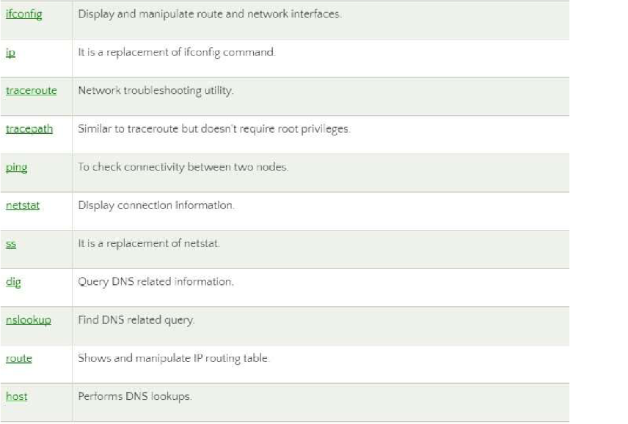

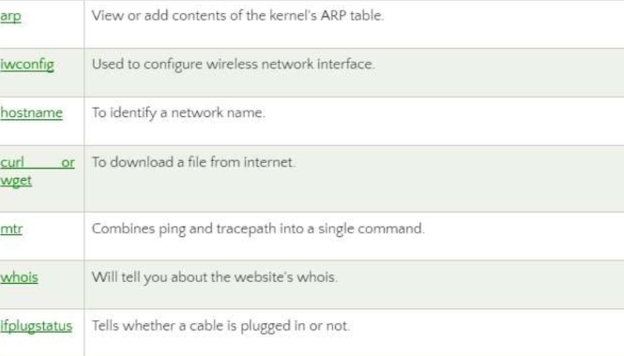

Explanation of the above commands:

1.ifconfig: ifconfig is short for interface configurator. This command is utilized in network inspection, initializing the interface, enabling or disabling an IP address, and configuring an interface with an IP address. Also, it is used to show the network and route interface. The basic details shown with ifconfig are:

MTU

MAC address

IP address

Syntax:

Ifconfig

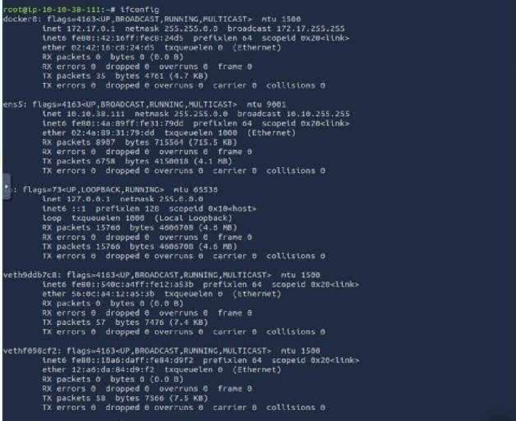

2. ip: It is the updated and latest edition of ifconfig command. The command provides the information of every networks such as ifconfig. Also, it can be used to get information about a particular interface. Syntax:

ip a 1.

2. ip addr

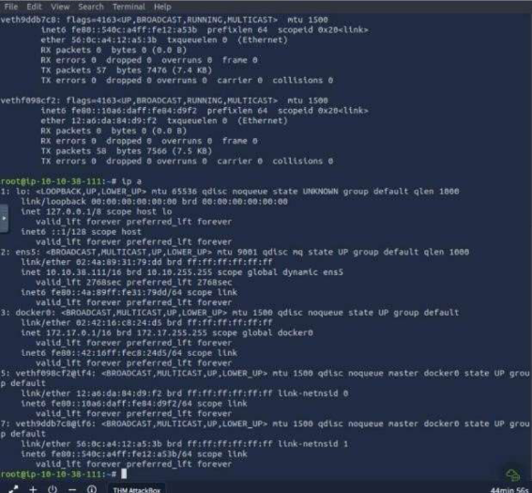

3. traceroute: The traceroute command is one of the most helpful commands in the networking field. It's used to balance the network. It identifies the delay and decides the pathway to our target. Basically, it aids in the below ways:

It determines the location of the network latency and informs it.

It follows the path to the destination.

It gives the names and recognizes all devices on the path.

Syntax:

traceroute <destination>

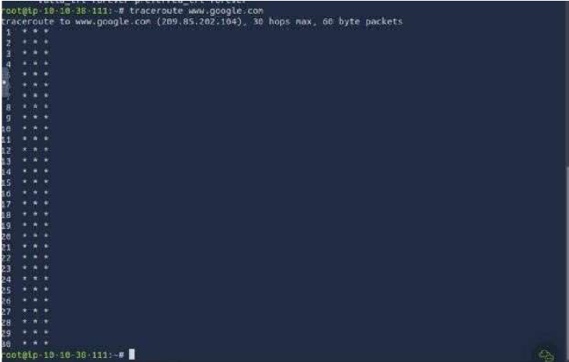

4. tracepath: The tracepath command is the same as the traceroute command, and it is used to find network delays. Besides, it does not need root privileges. By default, it comes preinstalled in Ubuntu. It traces the path to the destination and recognizes all hops in it. It identifies the point at which the network is weak if our network is not strong enough.

Syntax: tracepath

<destination>

Applications

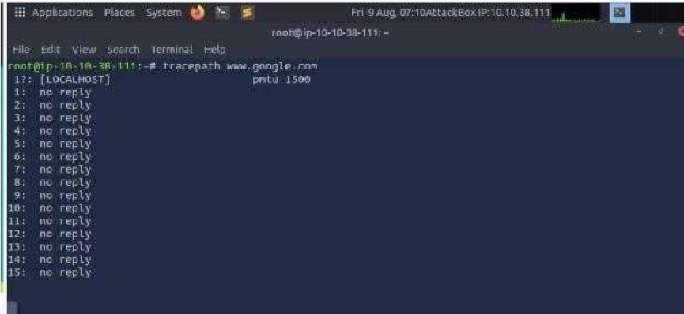

5. ping: It is short for Packet Internet Groper. The ping command is one of the widely used commands for network troubleshooting. Basically, it inspects the network connectivity between two different nodes.

Syntax: ping

<destination>

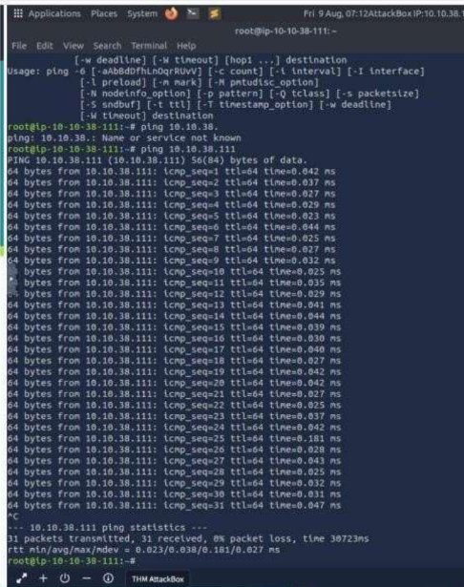

6.netstat: It is short for network statistics. It gives statistical figures of many interfaces, which contain open sockets, connection information, and routing tables.

Syntax: Netstat

